Low-Light Image Enhancement Using Classical Digital Image Processing Technique
Vadlamudi Tharun Sai
Computer Science and Engineering VIT-AP University
Amaravati, Andhra Pradesh, India tharun.23bce7760@vitapstudent.ac.in

Goppireddy Lalith Reddy Computer Science and Engineering VIT-AP University
Amaravati, Andhra Pradesh, India lalith.23bce7469@vitapstudent.ac.in
Dr. M. Sucharitha (Faculty Advisor)
Associate Professor Grade 2
School of Electronics Engineering (SENSE)
VIT-AP University Amaravati ,India
sucharitha.jackson@vitap.ac.

Abstract - Images captured under low ambient illumination suffer from a compressed dynamic range, weak edge contrast, colour distortion and amplified sensor noise. Although deep-learning enhancers dominate recent benchmarks, classical Digital Image Processing (DIP) techniques remain attractive where deterministic behaviour, zero training data and low computational cost are required. This paper presents a comparative empirical study of four classical enhancement methods: gamma correction accelerated by an 8-bit look-up table, global histogram equalization of the luminance channel in YCrCb space, Contrast Limited Adaptive Histogram Equalization (CLAHE) on the L* channel of CIE-LAB space, and Single-Scale Retinex (SSR). An experimental hybrid pipeline that cascades gamma correction, CLAHE and fast non-local means denoising is also evaluated. All methods are tested on the 15 paired images of the LOL eval15 split using PSNR, SSIM, Shannon entropy, mean brightness, mean contrast and CPU runtime. SSR (σ = 80) obtains the highest mean PSNR (14.9707 dB), whereas gamma correction (γ = 0.4) obtains the highest mean SSIM (0.6196) at 0.0018 s per 400 × 600 image. The hybrid pipeline gives the highest entropy (6.7719) and an SSIM (0.6179) close to that of gamma correction, but it does not exceed the best single methods in PSNR and is the slowest (0.7487 s). Because the PSNR differences among the leading methods are small compared with the scene-to-scene spread, no method is claimed to be uniformly best; the results instead show clear trade-offs between fidelity, structural preservation and speed.
Keywords - Digital Image Processing; Low-Light Image Enhancement; Gamma Correction; Histogram Equalization; CLAHE; Single-Scale Retinex; LOL Dataset; PSNR; SSIM.
I. Introduction
Image acquisition under low ambient light is one of the most common degradation problems in digital imaging. During an exposure of duration Δt, each photosite of the sensor records a signal that can be modelled as
$$S(x,y)=η·Φ(x,y)·Δt+η_{Poisson}+η_{Gaussian}$$ | (1)
where Φ(x,y) is the scene irradiance, η is the quantum efficiency, η_{Poisson} is photon shot noise and η_{Gaussian} represents read-out and thermal noise [1]. In a dark scene Φ is small, so the signal-to-noise ratio (SNR) is low and most of the scene information is quantized into the lowest few intensity levels of an 8-bit image.
Brightening such an image presents a dilemma. Increasing the gain, in the camera or in post-processing, reveals hidden content but amplifies the noise together with the signal, whereas strong spatial smoothing suppresses the noise at the cost of edges and fine texture. An enhancement method therefore has to raise the global illumination, recover local contrast and limit noise amplification at the same time.
Deep-learning enhancers such as RetinexNet [2], Zero-DCE [3] and EnlightenGAN [4] currently dominate public benchmarks. They need training data and considerable compute, and their behaviour is harder to interpret. Classical DIP methods, in contrast, are explicit mathematical operations that need no training data, execute deterministically and are inexpensive to compute, which makes them natural baselines and candidates for resource-constrained pipelines [1]. Knowing how they compare with one another under identical conditions is therefore still useful, both for practical method selection and for understanding the principles on which more complex methods are built.
Problem statement. Given a low-light RGB image and a paired normal-light reference of the same scene, the task is to produce an enhanced image that is close to the reference in fidelity and structure while keeping the computation low. This paper compares four classical methods (gamma correction, global histogram equalization, CLAHE and single-scale Retinex) and one experimental hybrid pipeline on the LOL benchmark [2]. The contributions of this paper are as follows:
- Implementation and evaluation of four classical enhancement methods under one common protocol on the 15 paired LOL eval15 images.
- Formulation of an experimental hybrid pipeline that cascades gamma correction, CLAHE on the L* channel and fast non-local means denoising, and its comparison with the single-method baselines.
- Multi-metric analysis using PSNR, SSIM, Shannon entropy, mean brightness, mean contrast and CPU runtime, including a discussion of why PSNR and SSIM rank the methods differently.
- Visual and histogram analysis of the behaviour of each method, together with an explicit statement of the limitations of the study.
The organization of the paper is as follows. Section II gives the methodology, including the mathematical formulation of each method, the hybrid pipeline and the evaluation metrics. Section III describes the dataset and experimental setup and presents the results. Section IV gives the conclusions, and Section V discusses limitations and future work.
II. Methodology
Five enhancement pipelines are applied to every low-light image of the dataset, and each output is compared with the paired ground truth using the metrics of Section II-F. The workflow of the proposed hybrid pipeline is shown in Fig. 1; the four baselines are applied to the same inputs.
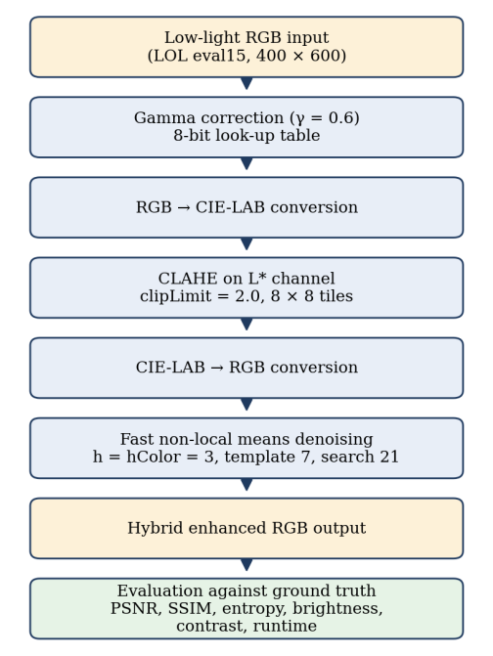
Fig. 1. Workflow of the proposed hybrid pipeline and its evaluation.
A. Power-Law (Gamma) Correction with a Look-Up Table
Gamma correction is a point operation [1] that maps a normalized input intensity r ∈ [0, 1] to an output s ∈ [0, 1] as
$$s=c·r^{γ}$$ | (2)
with c = 1 and γ > 0. Differentiating gives
$$\frac{ds}{dr}=c·γ·r^{γ−1}$$ | (3)
For γ < 1 the slope exceeds one for small r, so narrow dark intensity intervals are stretched over a wider output range while highlights are compressed. For γ > 1 dark values are compressed, and γ = 1 is the identity. The standalone method uses γ = 0.4.
Because 8-bit images take only 256 distinct values, the power function need not be evaluated for every pixel. A look-up table (LUT) is computed once for k = 0, 1, …, 255 as
$$LUT[k]=clip(255·{\left(\frac{k}{255}\right)}^{γ},0,255)$$ | (4)
and applied by array indexing (cv2.LUT), so that the per-pixel cost reduces to one memory lookup after a 256-entry precomputation.
B. Global Histogram Equalization in the YCrCb Domain
Histogram equalization (HE) seeks a monotonic mapping T(r) whose output has a uniform probability density over the L gray levels [1]. The continuous mapping uses the cumulative distribution function:
$$s=T(r)=(L−1)\int_{0}^{r}{p_{r}(w)dw}$$ | (5)
For an M × N image in which n_{j} pixels have level r_{j}, the discrete mapping is
$$s_{k}=T(r_{k})=(L−1)\sum_{j=0}^{k}{p_{r}(r_{j})}=\frac{L−1}{MN}\sum_{j=0}^{k}{n_{j}}$$ | (6)
Applying HE separately to R, G and B changes the ratios between the channels and produces colour shifts. The image is therefore converted to YCrCb,
$$Y=0.299R+0.587G+0.114B$$ | (7)
$$Cr=0.713(R−Y)+128$$ | (8)
$$Cb=0.564(B−Y)+128$$ | (9)
HE is applied to the luminance channel Y only, and the image is converted back to RGB with Cr and Cb unchanged. Because a single mapping is used for the whole image, noisy dark regions are stretched together with informative ones.
C. Contrast Limited Adaptive Histogram Equalization (CLAHE)
Adaptive histogram equalization (AHE) [5] computes mappings from local regions but over-amplifies noise in homogeneous areas. CLAHE [6], [7] limits this effect in three steps. (i) Tile partitioning: the image is divided into non-overlapping contextual tiles, here 8 × 8. (ii) Histogram clipping: in each tile histogram h(k), the bins above a clip limit β are truncated and the clipped mass is redistributed uniformly over the 256 bins:
$$M_{clip}=\sum_{k=0}^{255}{max(0,h(k)−β)}$$ | (10)
$$h′(k)=min(h(k),β)+\frac{M_{clip}}{256}$$ | (11)
In the OpenCV implementation the clipLimit argument (2.0 here) is a normalized value that is converted internally to an absolute limit β per tile. (iii) Bilinear interpolation: to avoid visible seams between tiles, each output pixel is obtained by bilinear interpolation of the mappings of the four nearest tile centres, weighted by distance. As with HE, CLAHE is applied only to the L* channel of the CIE-LAB space, leaving a* and b* unchanged.
D. Single-Scale Retinex (SSR)
Retinex theory, introduced by Land and McCann [8] and described in Land’s later article [9], models an observed image as the product of illumination L(x, y) and surface reflectance R(x, y):
$$I(x,y)=L(x,y)·R(x,y)$$ | (12)
Illumination varies slowly across the scene, whereas reflectance carries the intrinsic properties of objects. Taking logarithms turns the product into a difference:
$$log R(x,y)=log I(x,y)−log L(x,y)$$ | (13)
In the single-scale Retinex of Jobson et al. [10], the illumination is estimated by convolving the image with a normalized Gaussian surround of scale σ:
$$G_{σ}(x,y)=\frac{1}{2πσ^{2}}exp\left(−\frac{x^{2}+y^{2}}{2σ^{2}}\right)$$ | (14)
The retinex output is then
$$R_{SSR}(x,y)=log\left[I+ε\right]−log\left[\left(I+ε\right)∗G_{σ}\right]$$ | (15)
where * denotes convolution and ε = 1.0 prevents log(0). The result is mapped back to [0, 255] by per-channel min–max normalization:
$$R_{out}(x,y)=255·\frac{R_{SSR}(x,y)−minR_{SSR}}{maxR_{SSR}−minR_{SSR}}$$ | (16)
The scale σ controls the size of the surround: small values emphasize local contrast but can produce halos near strong edges, while large values give smoother illumination estimates and more natural tonal rendering [10]. A large scale, σ = 80, is used in this study.
E. Proposed Hybrid Pipeline
Each classical method has a distinct strength: gamma correction lifts the global illumination, CLAHE strengthens local contrast, and denoising limits the noise that the previous stages can amplify. The experimental hybrid pipeline (Fig. 1, Table I) cascades these operations. The input is brightened by gamma correction (γ = 0.6), converted to CIE-LAB, and CLAHE (clipLimit = 2.0, 8 × 8 tiles) is applied to L*. After conversion back to RGB, fast non-local means colour denoising [11] is applied with h = 3, hColor = 3, a 7 × 7 template window and a 21 × 21 search window. Non-local means replaces each pixel by a weighted average of pixels whose surrounding patches are similar, so its cost grows roughly with the product of the squared search and template window sizes; this explains the high runtime reported in Section III. The pipeline is a heuristic design with fixed parameters. The role of each stage described above is the design intent; no ablation of the individual stages is reported in this study.
TABLE I. Proposed Hybrid Enhancement Pipeline
Input: 8-bit RGB image I; γ = 0.6; clipLimit = 2.0; tiles 8 × 8; h = hColor = 3; template 7; search 21
Output: enhanced RGB image I_{out}
1. Build LUT[k] = clip(255(k/255)^{0.6}, 0, 255), k = 0…255
2. I₁ ← LUT(I) // global brightening
3. (L*, a*, b*) ← RGB→LAB(I₁)
4. L*′ ← CLAHE(L*; clipLimit, 8 × 8) // local contrast
5. I₂ ← LAB→RGB(L*′, a*, b*)
6. I_{out} ← fastNlMeansDenoisingColored(I₂; h, hColor, 7, 21)
7. return I_{out}

F. Evaluation Metrics
Every enhanced image is compared with its paired ground-truth image I_{ref}. The mean squared error over all three channels of an M × N image and the peak signal-to-noise ratio are
$$MSE=\frac{1}{3MN}\sum_{c=1}^{3}{\sum_{(i,j)}{{\left[I_{ref}−I_{enh}\right]}^{2}}}$$ | (17)
$$PSNR=10·\log_{10}\left(\frac{{255}^{2}}{MSE}\right)dB$$ | (18)
where the sum runs over all pixel positions (i, j) and colour channels c. The structural similarity index (SSIM) [12] compares luminance, contrast and structure of two image regions x and y:
$$SSIM(x,y)=\frac{(2μ_{x}μ_{y}+C_{1})(2σ_{xy}+C_{2})}{({μ_{x}}^{2}+{μ_{y}}^{2}+C_{1})({σ_{x}}^{2}+{σ_{y}}^{2}+C_{2})}$$ | (19)
where μ, σ² and σ_{xy} are means, variances and covariance, C₁ = (0.01 × 255)² and C₂ = (0.03 × 255)². This single-fraction form corresponds to the usual three-term decomposition with C₃ = C₂/2. The Shannon entropy of the 256-bin intensity histogram, with probabilities p(k), measures gray-level richness:
$$H=−\sum_{k=0}^{255}{p(k)·\log_{2}p(k)}$$ | (20)
Entropy is a no-reference measure, and a high value can also be caused by noise. Mean brightness is the average pixel intensity of the enhanced image, and mean contrast is the standard deviation of its pixel intensities, both computed on the grayscale (luminance) version of the image. Runtime is measured with time.perf_counter() around the enhancement call only, excluding file I/O, and throughput in frames per second (FPS) is the reciprocal of the mean runtime.
III. Experimental Results
A. Dataset and Experimental Setup
The Low-Light (LOL) dataset [2] contains paired low-light and normal-light photographs of real scenes, captured by varying the exposure time and ISO setting. The official evaluation split, eval15, which contains 15 pairs at 400 × 600 resolution, is used here. An automated verification step confirmed that all filenames match between the low-light and reference folders, that no file is unreadable and that the two images of every pair have identical dimensions. All methods are classical, so no model is trained; the 15 pairs are used only for evaluation. The settings are summarized in Table II.
The parameters were chosen as follows. In a calibration run on a single eval15 scene, γ was selected from {0.4, 0.6, 0.8, 1.0} and σ from {15, 30, 80}. On that scene γ = 0.4 gave an SSIM of 0.7266 and a PSNR of 13.93 dB, while σ = 15 and σ = 30 gave lower PSNR (10.09 dB and 10.57 dB) and visible halos, compared with 11.45 dB for σ = 80. The CLAHE settings follow common practice [6], and the hybrid parameters were fixed heuristically. Because the calibration scene belongs to the evaluation set and no separate validation split was used, the scores of the standalone methods may be slightly optimistic.
TABLE II. Experimental Settings
Parameter | Description / value
Dataset | LOL [2], eval15 split
Pairs / size | 15 pairs, 400 × 600
Gamma | γ = 0.4, 8-bit LUT (cv2.LUT)
Hist. equalization | Y channel of YCrCb only
CLAHE | L* of CIE-LAB; clipLimit 2.0; 8 × 8 tiles
SSR | σ = 80; ε = 1.0; per-channel min–max
Hybrid | γ = 0.6 → CLAHE (2.0, 8 × 8) → NLM (h = hColor = 3, 7, 21)
Metrics | PSNR, SSIM, entropy, brightness, contrast, runtime
Timer | time.perf_counter(), excludes I/O
Training | None (classical methods)
Parameter selection | Small calibration sweep on one scene; CLAHE from [6]; hybrid heuristic
Hardware | Local PC: Windows 11 Pro 64-bit, 16 GB RAM, x86-64 CPU @ 3.20 GHz
Software | OpenCV 4.11.0, NumPy 2.4.2, scikit-image 0.26.0
SSIM settings | skimage structural_similarity, channel_axis = 2, data_range = 255, channel average
Std. deviation | Sample (ddof = 1)

B. Quantitative Results
Table III gives the mean and standard deviation of each metric over the 15 scenes, and Figs. 2–4 show the PSNR, SSIM and runtime. SSR (σ = 80) obtains the highest mean PSNR (14.9707 dB), followed by gamma correction (14.5301 dB), HE (14.2356 dB), the hybrid pipeline (13.6609 dB) and CLAHE (9.1323 dB). The SSIM ranking differs: gamma correction (0.6196) and the hybrid pipeline (0.6179) are almost equal, followed by SSR (0.5899), HE (0.4252) and CLAHE (0.3565).
TABLE III. Mean Results on LOL eval15 (15 Images)
Metric | SSR  (σ=80) | Gamma  (γ=0.4) | HE  (YCrCb) | Hybrid | CLAHE  (LAB)
PSNR mean (dB) | 14.9707 | 14.5301 | 14.2356 | 13.6609 | 9.1323
PSNR std | 3.6755 | 4.3425 | 3.1378 | 4.1031 | 2.9591
SSIM mean | 0.5899 | 0.6196 | 0.4252 | 0.6179 | 0.3565
SSIM std | 0.1097 | 0.1162 | 0.1018 | 0.0987 | 0.1135
Runtime (s) | 0.1742 | 0.0018 | 0.0017 | 0.7487 | 0.0065
Throughput (FPS) | 5.7 | 555 | 588 | 1.3 | 153
Mean brightness | 144.89 | 73.18 | 130.79 | 67.49 | 29.75
Mean contrast | 33.51 | 25.24 | 73.64 | 31.97 | 16.80
Entropy (bits) | 6.7360 | 6.2015 | 4.7419 | 6.7719 | 5.5542
Bold = best value in the row (not applied to brightness and contrast, which have no “better” direction).
The PSNR differences among SSR, gamma correction and HE (0.3–0.7 dB) are small compared with the per-image standard deviations of 3.1–4.3 dB, and the SSIM difference between gamma correction and the hybrid pipeline is only 0.0017. The 15-image experiment therefore does not establish a clear separation among these methods, and no paired significance test was performed. CLAHE is clearly the weakest on both fidelity metrics, which is consistent with its low mean brightness (29.75): the L* channel is enhanced locally, but the overall exposure remains far from that of the reference.
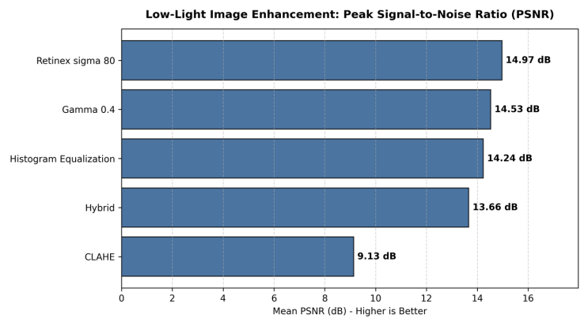
Fig. 2. Mean peak signal-to-noise ratio (PSNR) in dB.
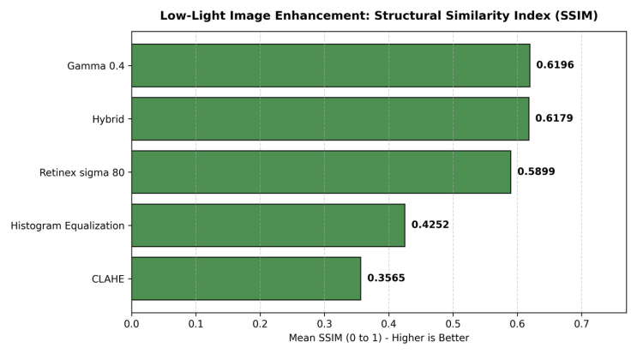
Fig. 3. Mean structural similarity index measure (SSIM).
HE has the highest contrast (73.64) but the lowest entropy (4.7419). A plausible explanation is that equalization of an 8-bit image is a many-to-one mapping that merges neighbouring occupied gray levels and leaves others empty, which can lower entropy even though the histogram spreads over the whole range (see Fig. 6); this was not tested separately. The hybrid pipeline (6.7719) and SSR (6.7360) have the highest entropy, but the difference between them is small.
Runtime per 400 × 600 image is 0.0017 s for HE, 0.0018 s for gamma correction, 0.0065 s for CLAHE, 0.1742 s for SSR and 0.7487 s for the hybrid pipeline (Fig. 4), i.e. approximately 588, 555, 153, 5.7 and 1.3 FPS. These values were measured on a local Windows 11 PC with an x86-64 CPU and 16 GB of RAM (Table II).
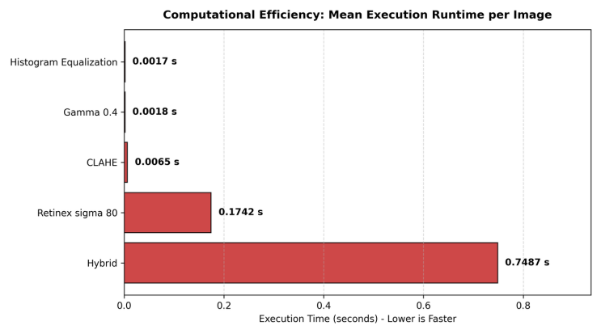
Fig. 4. Mean execution time per 400 × 600 image on a CPU (lower is faster).
C. Per-Scene Results
Table IV lists PSNR and SSIM of every method on each of the 15 scenes; its column means and sample standard deviations reproduce Table III. The scene-to-scene variation is large: the PSNR of gamma correction ranges from 8.11 to 22.66 dB and that of SSR from 9.72 to 20.49 dB. No method wins everywhere. SSR has the highest PSNR on 6 scenes, gamma correction on 5 and HE on 4, and for SSIM SSR leads on 6 scenes, gamma correction on 5 and the hybrid pipeline on 4. The paired PSNR difference between SSR and gamma correction has a mean of only 0.44 dB but a standard deviation of 6.9 dB across scenes, so their ranking is not reliable with 15 images.
D. Qualitative and Histogram Analysis
Fig. 5 compares the enhanced outputs for scene 1.png with the input and the reference, Fig. 6 shows the corresponding RGB histograms, and Fig. 7 shows the stages of the hybrid pipeline. A single scene is shown, so the observations below are illustrative and not statistically conclusive.

TABLE IV. Per-Scene PSNR (dB) / SSIM on LOL eval15
Scene | Gamma (γ=0.4) | HE (YCrCb) | CLAHE (LAB L*) | SSR (σ=80) | Hybrid
S1 (1.png) | 13.93 / 0.7266 | 17.42 / 0.6007 | 8.71 / 0.4328 | 11.45 / 0.6436 | 12.91 / 0.7205
S2 (111.png) | 11.68 / 0.6795 | 15.85 / 0.4667 | 6.74 / 0.3362 | 20.49 / 0.7345 | 10.61 / 0.6726
S3 (146.png) | 14.15 / 0.7460 | 15.49 / 0.4349 | 8.05 / 0.4339 | 16.13 / 0.7589 | 12.48 / 0.7360
S4 (179.png) | 19.16 / 0.7341 | 9.14 / 0.2678 | 14.81 / 0.6229 | 9.72 / 0.5510 | 18.74 / 0.6907
S5 (22.png) | 12.21 / 0.6553 | 19.86 / 0.5801 | 7.50 / 0.3829 | 13.85 / 0.6561 | 11.33 / 0.6883
S6 (23.png) | 8.35 / 0.4207 | 17.15 / 0.4146 | 5.36 / 0.1949 | 14.24 / 0.5257 | 8.05 / 0.4583
S7 (493.png) | 17.72 / 0.5382 | 9.96 / 0.3566 | 12.13 / 0.3065 | 11.08 / 0.3952 | 17.29 / 0.5384
S8 (547.png) | 18.30 / 0.6924 | 14.05 / 0.4181 | 10.59 / 0.4164 | 9.90 / 0.5070 | 16.92 / 0.7028
S9 (55.png) | 8.11 / 0.4164 | 16.26 / 0.4918 | 5.30 / 0.1972 | 18.74 / 0.5318 | 8.13 / 0.4618
S10 (665.png) | 11.65 / 0.4657 | 14.29 / 0.3187 | 7.71 / 0.2199 | 19.33 / 0.4964 | 11.05 / 0.4702
S11 (669.png) | 13.73 / 0.6641 | 14.99 / 0.3985 | 8.06 / 0.3474 | 14.05 / 0.6078 | 12.47 / 0.6172
S12 (748.png) | 20.63 / 0.7264 | 11.59 / 0.3784 | 11.64 / 0.4197 | 19.19 / 0.6710 | 19.36 / 0.6992
S13 (778.png) | 14.68 / 0.5182 | 13.05 / 0.4811 | 10.04 / 0.2479 | 16.59 / 0.5546 | 14.61 / 0.5661
S14 (780.png) | 22.66 / 0.6337 | 9.23 / 0.2552 | 13.93 / 0.4223 | 11.72 / 0.4654 | 20.92 / 0.5780
S15 (79.png) | 10.98 / 0.6766 | 15.20 / 0.5148 | 6.42 / 0.3668 | 18.09 / 0.7500 | 10.05 / 0.6677
Mean | 14.5301 / 0.6196 | 14.2356 / 0.4252 | 9.1323 / 0.3565 | 14.9707 / 0.5899 | 13.6609 / 0.6179
Std. dev. | ± 4.3425 / ± 0.1162 | ± 3.1378 / ± 0.1018 | ± 2.9591 / ± 0.1135 | ± 3.6755 / ± 0.1097 | ± 4.1031 / ± 0.0987
Mean and standard deviation rows are those of Table III (sample standard deviation).
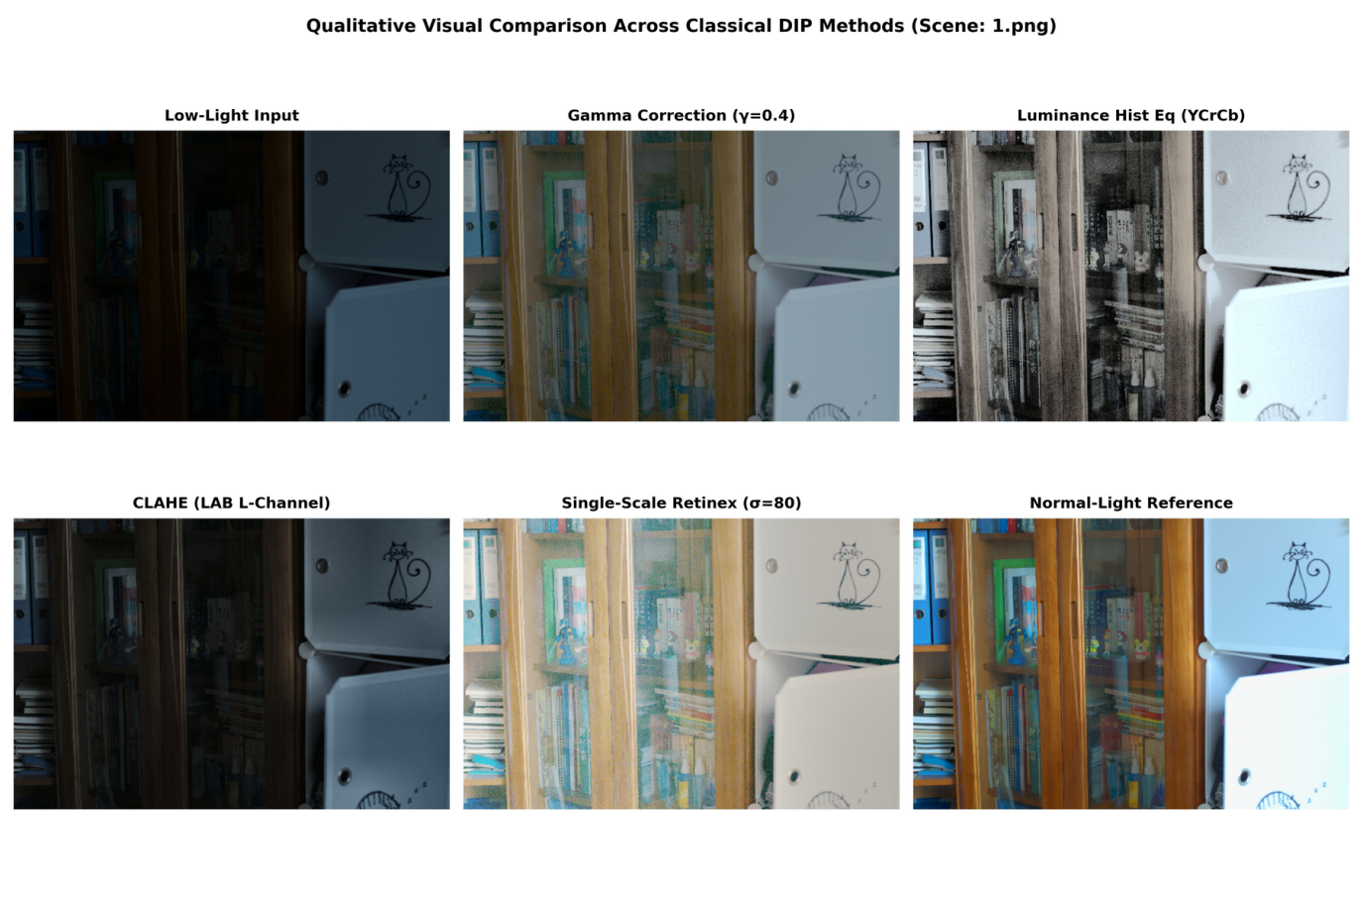
Fig. 5. Qualitative comparison on scene 1.png: low-light input, gamma correction (γ = 0.4), luminance HE (YCrCb), CLAHE (L* of LAB), SSR (σ = 80) and the normal-light reference.
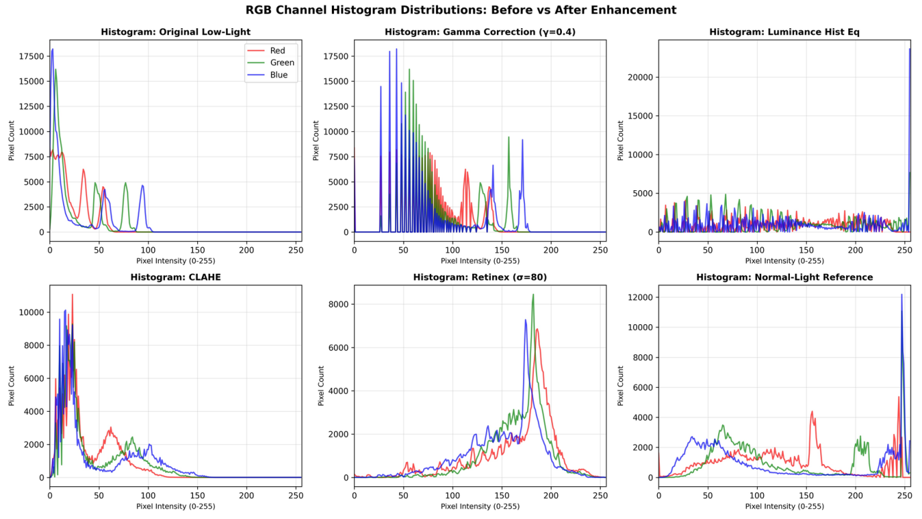
Fig. 6. RGB channel histograms of the input, the four enhanced outputs and the reference, showing dynamic-range stretching and clipping behaviour.
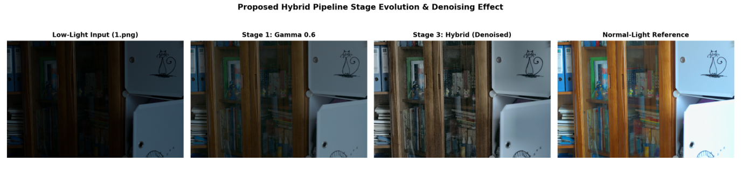
Fig. 7. Hybrid pipeline on scene 1.png: input, output of the gamma stage (γ = 0.6), final hybrid output (gamma, CLAHE and non-local means) and the normal-light reference.

Input. The image is heavily underexposed; shadow textures such as the book spines are barely visible, and the histogram is concentrated at the low end (Fig. 6).
Gamma correction (γ = 0.4). The brightening is uniform and preserves the relative tonal relations and edges without halo artifacts. The output is still darker and less saturated than the reference, and its histogram shows comb-like gaps because the LUT spreads the sparsely occupied input levels over a wider range.
Histogram equalization. Brightness and contrast increase strongly (mean 130.79), but the result looks almost desaturated, dark regions show amplified grain, and the spike at the upper end of the histogram indicates saturated highlights.
CLAHE. Local edges, text and silhouettes are crisper, but the overall brightness remains low (mean 29.75), so the global shadow illumination stays underexposed.
SSR (σ = 80). Shadows and highlights are brightened evenly and the histogram moves to the mid and upper range. In this scene, however, the colours appear less saturated and slightly hazy compared with the reference.
Hybrid pipeline. Fig. 7 shows the input, the output of the gamma stage (γ = 0.6) and the final hybrid output. The final output is brighter than the gamma-only stage and shows more local detail on the book spines and shelf edges, but it remains darker and less saturated than the reference, and some grain-like texture is still visible on the wooden surfaces. Because no panel after the CLAHE stage alone is shown and no noise metric was computed, the figure does not isolate the effect of the denoising stage; the idea that non-local means removes the noise amplified by CLAHE is the design intent and is not demonstrated here. Numerically, the pipeline reaches an SSIM close to that of gamma correction and the highest entropy (Table III). The histogram of its output was not generated.
E. Discussion
PSNR versus SSIM. The two metrics rank SSR and gamma correction in opposite order. PSNR depends only on the pixel-wise squared error and penalizes global exposure offsets heavily, whereas SSIM compares local luminance, contrast and structure. SSR separates illumination from reflectance and corrects spatially varying lighting, which can reduce the pixel-wise error over large regions. Gamma correction is a strictly monotonic point mapping that applies no spatial filtering and therefore preserves the ordering of intensities and local structure, which can explain its higher SSIM; the Gaussian surround filtering of SSR can alter local contrast near boundaries. These explanations are consistent with the measured values but were not tested in isolation. HE obtains a PSNR close to that of gamma correction but a much lower SSIM (0.4252 versus 0.6196); its strong stretching of dark noise and its saturated highlights (Fig. 6) are a plausible cause.
Quality–latency trade-off. The methods fall into three groups. HE and gamma correction run in about 2 ms per image (more than 550 FPS on the CPU used) and are the cheapest options. CLAHE (153 FPS) is also fast but, with the settings used, leaves the image too dark. SSR (5.7 FPS) gives the best PSNR at a much higher cost, and the hybrid pipeline (1.3 FPS) is slowest because of non-local means denoising. Whether these figures would carry over to embedded or automotive hardware was not tested in this study.
Overall. No method is uniformly best. SSR is best in PSNR, gamma correction is best in SSIM and is nearly the cheapest, HE is the fastest but gives poor structural similarity and desaturated colour, CLAHE alone does not correct the exposure, and the hybrid pipeline combines near-best SSIM with the highest entropy but is neither best in PSNR nor fast.
IV. Conclusions
This paper compared four classical DIP methods (gamma correction, luminance histogram equalization, CLAHE and single-scale Retinex) and an experimental hybrid pipeline for low-light image enhancement on the 15 paired LOL eval15 images. SSR (σ = 80) achieved the highest mean PSNR (14.9707 dB), and gamma correction (γ = 0.4) achieved the highest mean SSIM (0.6196) with a runtime of 0.0018 s per image. The hybrid pipeline reached an SSIM of 0.6179 and the highest entropy (6.7719) but not the best PSNR, and it was the slowest method (0.7487 s). CLAHE with the chosen settings produced the lowest PSNR and SSIM and left the images dark. The divergence between the PSNR and SSIM rankings shows that a single metric is not sufficient to select an enhancement method, and the runtime results show clear quality–latency trade-offs. Because the differences among the leading methods are small relative to the scene-to-scene variation, the results should be read as a comparison of tendencies rather than as proof of the superiority of any single method.
V. Limitations and Future Work
Several limitations should be acknowledged. The evaluation uses only 15 images from one dataset, and no statistical significance test was performed. The parameters (γ = 0.4, σ = 80, clipLimit = 2.0 and the hybrid settings) were fixed after a small calibration sweep on one scene that is part of the evaluation set, without a separate validation split, and the hybrid parameters were set heuristically with no ablation of its stages, so the results may not represent the best achievable performance of each technique. Only full-reference metrics, entropy, brightness and contrast were used; no no-reference perceptual metric or noise measure was evaluated, and the hybrid output is shown for one scene only. Runtime was measured on one CPU configuration in a high-level language and may differ on embedded hardware. Single-scale Retinex can reduce colour saturation, and no deep-learning baseline was included. Future work will therefore include parameter tuning and ablation studies, multi-scale Retinex variants, adaptive choice of γ, paired significance tests, additional metrics and datasets, comparison with learning-based enhancers, and benchmarking on resource-constrained devices.
References
[1] R. C. Gonzalez and R. E. Woods, Digital Image Processing, 4th ed. Pearson Education, 2018.
[2] C. Wei, W. Wang, W. Yang, and J. Liu, “Deep Retinex decomposition for low-light enhancement,” in Proc. British Machine Vision Conf. (BMVC), 2018.
[3] C. Guo, C. Li, J. Guo, C. C. Loy, J. Hou, S. Kwong, and R. Cong, “Zero-reference deep curve estimation for low-light image enhancement,” in Proc. IEEE/CVF Conf. Comput. Vis. Pattern Recognit. (CVPR), 2020, pp. 1780–1789.
[4] Y. Jiang et al., “EnlightenGAN: Deep light enhancement without paired supervision,” IEEE Trans. Image Process., vol. 30, pp. 2340–2349, 2021.
[5] S. M. Pizer, E. P. Amburn, J. D. Austin et al., “Adaptive histogram equalization and its variations,” Comput. Vis., Graph., Image Process., vol. 39, no. 3, pp. 355–368, 1987.
[6] K. Zuiderveld, “Contrast limited adaptive histogram equalization,” in Graphics Gems IV, P. S. Heckbert, Ed. San Diego, CA, USA: Academic Press, 1994, pp. 474–485.
[7] A. M. Reza, “Realization of the contrast limited adaptive histogram equalization (CLAHE) for real-time image enhancement,” J. VLSI Signal Process. Syst., vol. 38, no. 1, pp. 35–44, 2004.
[8] E. H. Land and J. J. McCann, “Lightness and retinex theory,” J. Opt. Soc. Amer., vol. 61, no. 1, pp. 1–11, 1971.
[9] E. H. Land, “The retinex theory of color vision,” Sci. Amer., vol. 237, no. 6, pp. 108–128, 1977.
[10] D. J. Jobson, Z. Rahman, and G. A. Woodell, “Properties and performance of a center/surround retinex,” IEEE Trans. Image Process., vol. 6, no. 3, pp. 451–462, 1997.
[11] A. Buades, B. Coll, and J.-M. Morel, “A non-local algorithm for image denoising,” in Proc. IEEE Comput. Soc. Conf. Comput. Vis. Pattern Recognit. (CVPR), vol. 2, 2005, pp. 60–65.
[12] Z. Wang, A. C. Bovik, H. R. Sheikh, and E. P. Simoncelli, “Image quality assessment: From error visibility to structural similarity,” IEEE Trans. Image Process., vol. 13, no. 4, pp. 600–612, 2004.

